Individual Profiles

My name is James Humphry, my email is s3949637@student.rmit.edu.au. I have successfully completed VCE and am currently studying a Bachelor of Information Technology at RMIT. I am a native English speaker and can speak a very small amount of French due to learning it at school. I am an avid reader of light novels and I play a lot of video games, specifically role-playing games but I do play other things sometimes

Myer Briggs <https://www.16personalities.com/profile> – Logician Introverted – 84%, Intuitive – 52%, Thinking – 54%, Prospecting – 54%, Turbulent – 72%,

Role: Analyst,

Strategy: Constant Improvement.

Learning Style Test <<http://www.educationplanner.org/index.html>> – Visual – 40%, Auditory – 40%, Tactile, 20%

Big 5 Personality Test <<http://www.educationplanner.org/index.html>> – Neuroticism – 88(High), Extraversion – 45(Low), Openness to Experience – 74(High), Agreeableness – 84(High), Conscientiousness – 72(Neutral)

My Name is Tony Le (s3941202) I was born and raised in Australia, but I come from a Vietnamese background. My hobbies include playing video games (mostly League of Legends, CSGO and Valorant), reading manga and watching Netflix. My interest in IT lies in the development of games and just programming in general. In the future I would like to develop pixel games and applications that would of convenience to other people’s everyday lives. I don’t have much IT experience currently, but I am excited to learn more about programming throughout my course.

Myer Briggs < <https://www.16personalities.com/profile>> - Turbulent Adventurer – Introverted (69%), Observant (57%), Feeling (67%), Prospecting (78%), Turbulent (65%)

Learning Style Test <<http://www.educationplanner.org/index.html>> -- Visual (45%), Auditory (25%), Tactile (30%)

Big Five Personality Test < <https://www.truity.com/test/big-five-personality-test> > -- Neuroticism (65%), Extraversion (19%), Openness (60%), Conscientiousness (33%), Agreeableness (71%)

My name is Matthew Shanahan, but normally I go by Matt. I am studying a Bachelor of Information Technology at RMIT. Ever since I was young, I have had a passion for video games and slowly that evolved into a passion for everything IT. During high school I taught myself python and HTML as hobbies because that’s just what I was interested in at the time. During my free time you can usually find me playing video games or trampolining, although I've recently picked up skating as well. In the future I hope to be able to work on software solutions in fields that interest me.

**Sithira**

My name is Sithira Deelaka. I was born and raised in Sri Lanka. Then I did my diploma of IT in a college in Sri Lanka and I came to RMIT to complete my Bachelors in Information Technology. My hobbies are playing video games such as valorant, call of Duty etc and in summerdays I play cricket for club as a wicketkeeper batsmen. My interesting in IT in the area of software developing. I’mm very good in programming languages such as Java, JavaScript, python, HTML, C++,C#.

*The Myers Briggs personality test* result (INFJ) Advocate --> Extraverted 65%, Observant– 51%, Feeling – 60%, Judging– 54%, <https://www.16personalities.com/>

Learning Style Test—Pragmatist (25%), Theorist(25%), Reflector(25%), Activist(19%)

Leadership Test - <https://eml.usc.edu/leadership-style-quiz> - Result: Front Line Leader

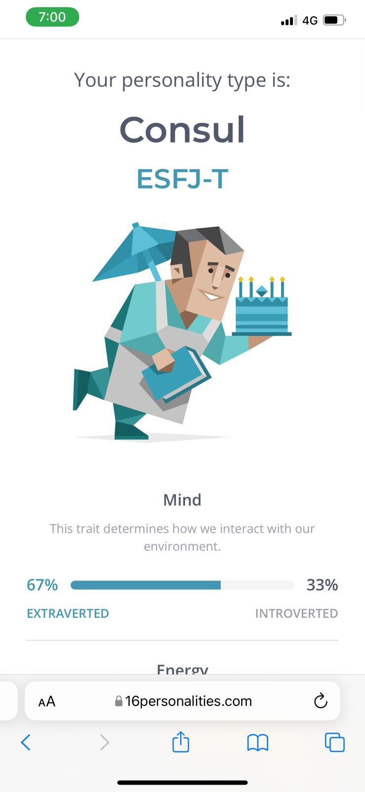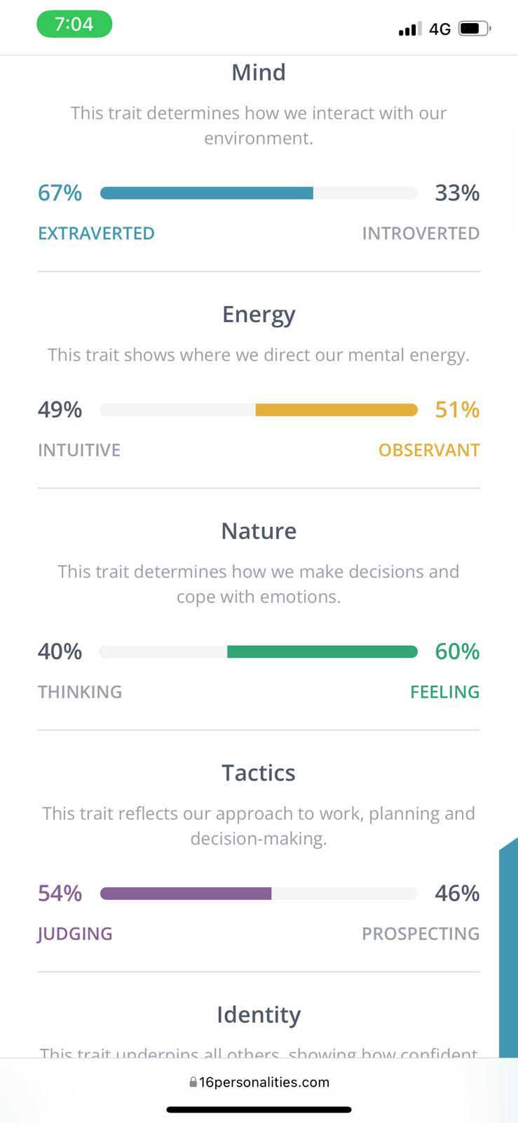

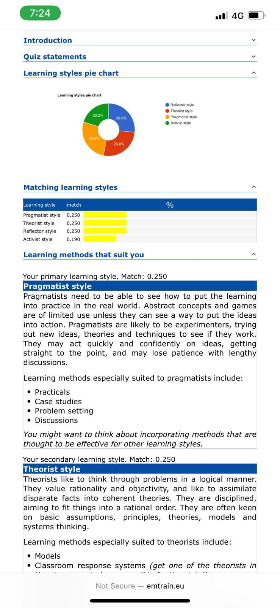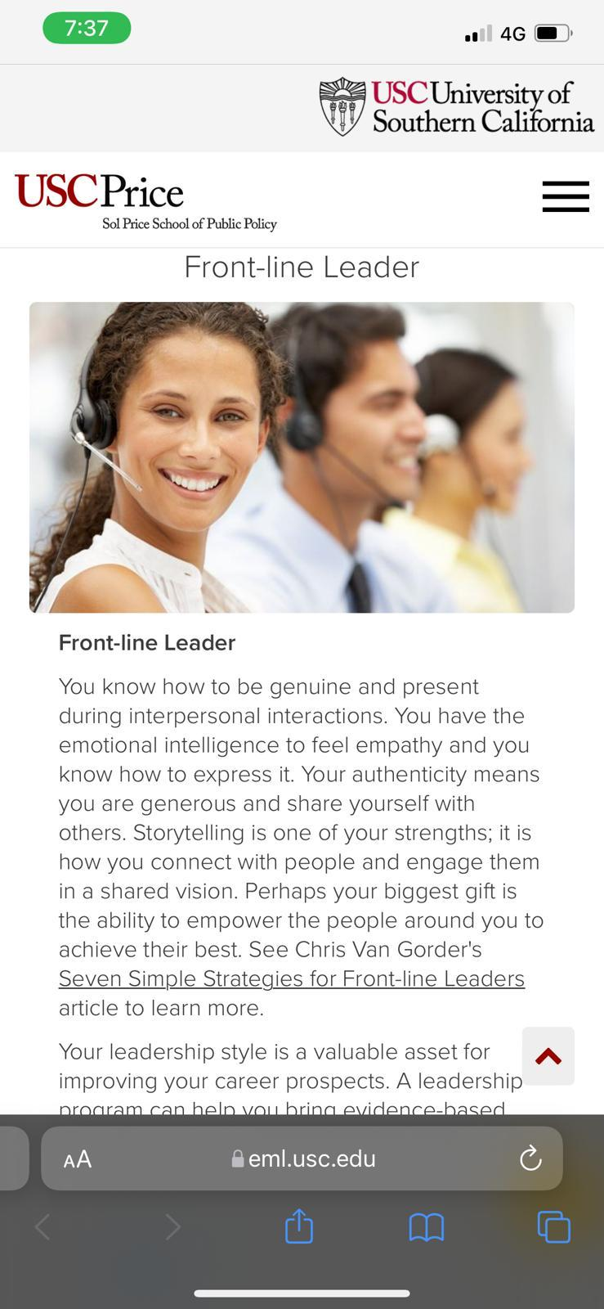

**Michael**

My name is Michael McKeown, my interest in It was stoked from a young age, having built a PC in my early years, messing around with programming, gaming and fault finding.  
  
I appreciate the concept of programming as there is an infinite number of possibilities, your skill and imagination are the only limit to what you can accomplish.  
  
I enjoy long drives, loud music, and good coffee.  
  
Automation is what draws me to study IT at RMIT, as someone who likes to find an easier way of doing things, what is easier than something that does itself?

*The Myers Briggs personality test* result (INFJ) Advocate --> Introverted 64%, Intuitive – 84%, Feeling – 67%, Judging– 51%, Assertive– 61% -- <https://www.16personalities.com/>

Learning Style Test <<http://www.educationplanner.org/index.html>> – Identified as a tactile learner.

Big Five Personality Test -- Result: Openness: High, Conscientiousness: Low, Extraversion: Low, Agreeableness: Low, Neuroticism: High